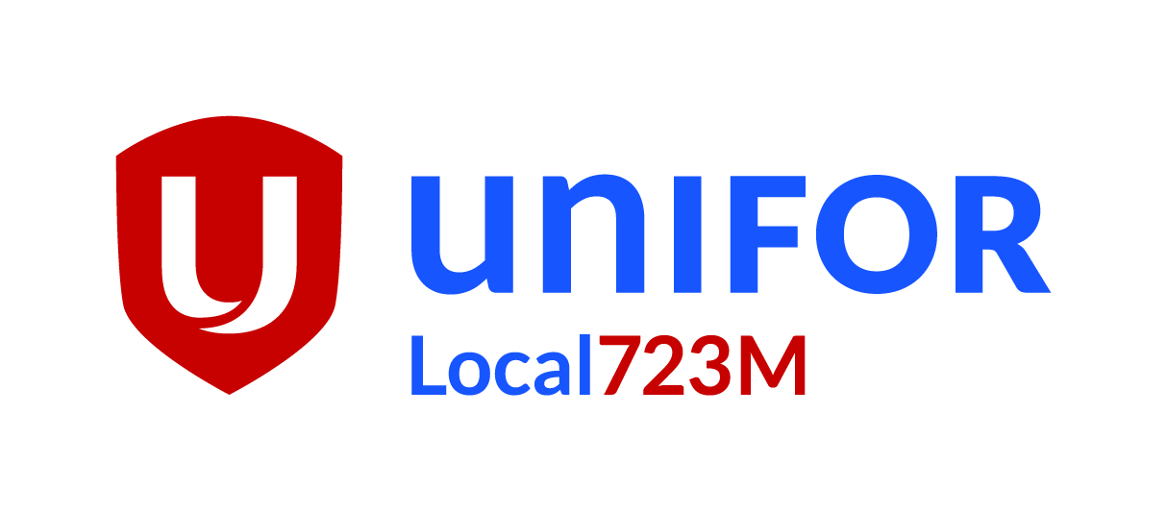
Executive Board
Motion #_4__

06/4/2019 | Motion
W
Motion to elect 4 delegates and 1 Alternate. To Convention in Quebec City, Aug 19 to 23,2019.

5
 | Motion By:
Angelo
 | 2nd By:
Mike N
 | Votes For:
11
 | Votes Against:
21
 | Abstention:
2
 | Passed

