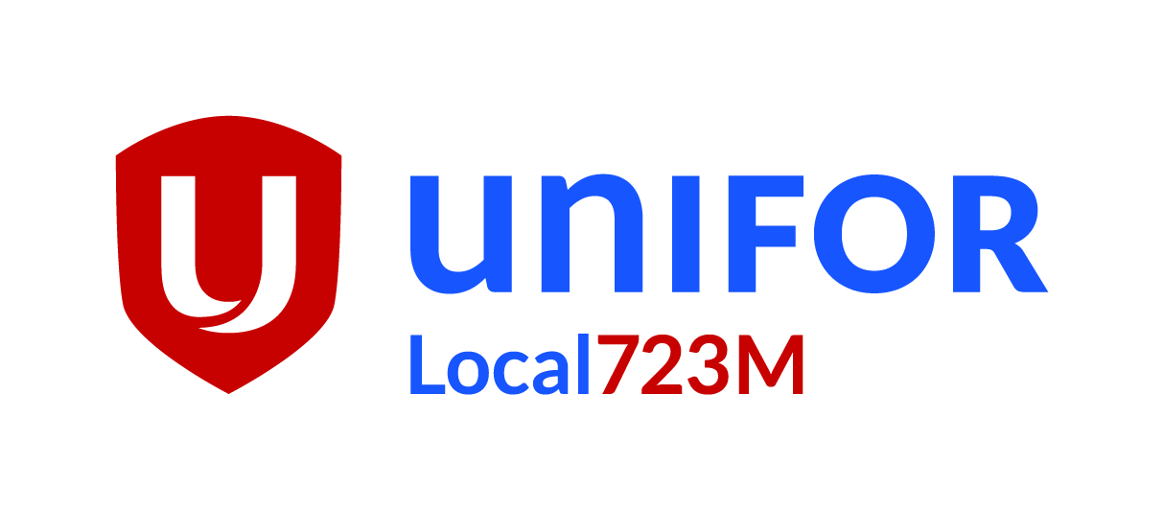

Agenda
Executive Board Meeting
Tuesday June 04 , 2019

18:00 | Call to Order and Minutes of August Meeting
House keeping- Reports must be in 1 week before meeting. If you’re are not able attend, give as much notice as possible.
Make sure office is presentable to guests.
Organizing
Minutes from last meeting- Approved as amended
New Steward installation, Camila Garcia and Adam Slinn
18:15 | Officer Reports
President Angelo Contarin- Passed

Bell Unit VP Kat Leonard- Passed
Rogers City Unit VP Carl Davis- Passed
Rogers OMNI Unit VP Rinaldo Boni- Passed
Local Treasurer Joshua Filipe – Oral Report – Passed

Motion to go incamera. –18:55 Seconded – Frank Barron- Passed
Return from in camera – 19:10 Seconded- Campoli – passed
Break
18:50 | Committee and Delegate Reports
H&S committees Rogers and Bell Luc Wilson – Passed
New H&S Rep Adesh Bridgmohan and Sean Webb.
Opening for Rep at DSQ.
Thanks for Luc’s work on H&S and as a Steward.

19:00 | Tabled Motions
Motion #1 – CDLS Foundation- Seconded Mike N – Passed 14-0
Motion #2 – walk for diabetes – Seconded Nate S – Passed 14-0
Motion #3 – Friends of Canadian Broadcasting -Seconded Nate – Passed 11-2-1

 | New Buisness
- CTV 299 Queen Mental Health – MMVAs
Kat and Chris will work together to get an action plan by next eboard.
- Local Standing Committee on H&S

- Constitutional Convention 2019 in Quebec City aug 19,2019,- 4 delegates 1 alternate -passed 11,1,2
- June Jubilee. Raptor games, food, tell your friends.
- Map info sessions- info at office and at General Membership meetings. Signs at jubilee, part of announcements at party.
Member orientation- Held Monthly at local office for all members. Topics like what national do for you, what local does for members.
- Membership Training – Do survey to get idea what members would like learn. More work on this.
- New Steward Training – August 11-16 Adam and Camila
 | Old Business
- Dues policy for over scale- no change.
- Constitutional Convention QC 2019- done to death

- Kids Xmas party- Going Good, on track.
- Unifor Education – for courses contact Sandra Benain
- Trustee meeting- coming soon

 | Open Floor
- Next E-Board Meeting – July 17,2019
- Next General Membership – July 23-24,2019

22:00 | Motion to Adjourn
Server

